Q1:

ORG 0000H

0000| MOV R0,#48H

0002| MOV R1,#48H

0004| MOV R2,#8H

0006| MOV R3,#9H

0008| MOV R4,#6H

000A| MOV R5,#12H

000C| MOV R6,#9H

000E| MOV A,R0

000F| MOV P1,R0

0011| ACALL DELAY

0013| MOV P2,R1

0015| ACALL DELAY

0017| MOV P2,#00H

001A| MOV P1,R2

001C| ACALL DELAY

001E| MOV P1,R3

0020| ACALL DELAY

0022| MOV P1,R4

0024| ACALL DELAY

0026| MOV P1,R5

0028| ACALL DELAY

002A| MOV P1,R6

002C| ACALL DELAY

DELAY:

002E| MOV R7,#7H

0030| RET

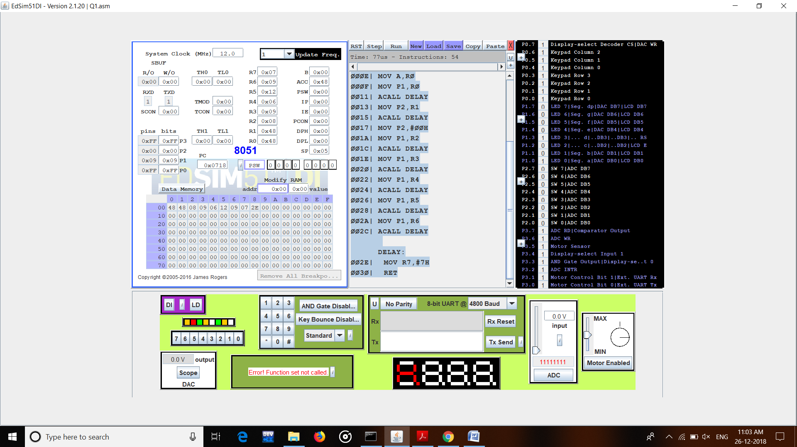

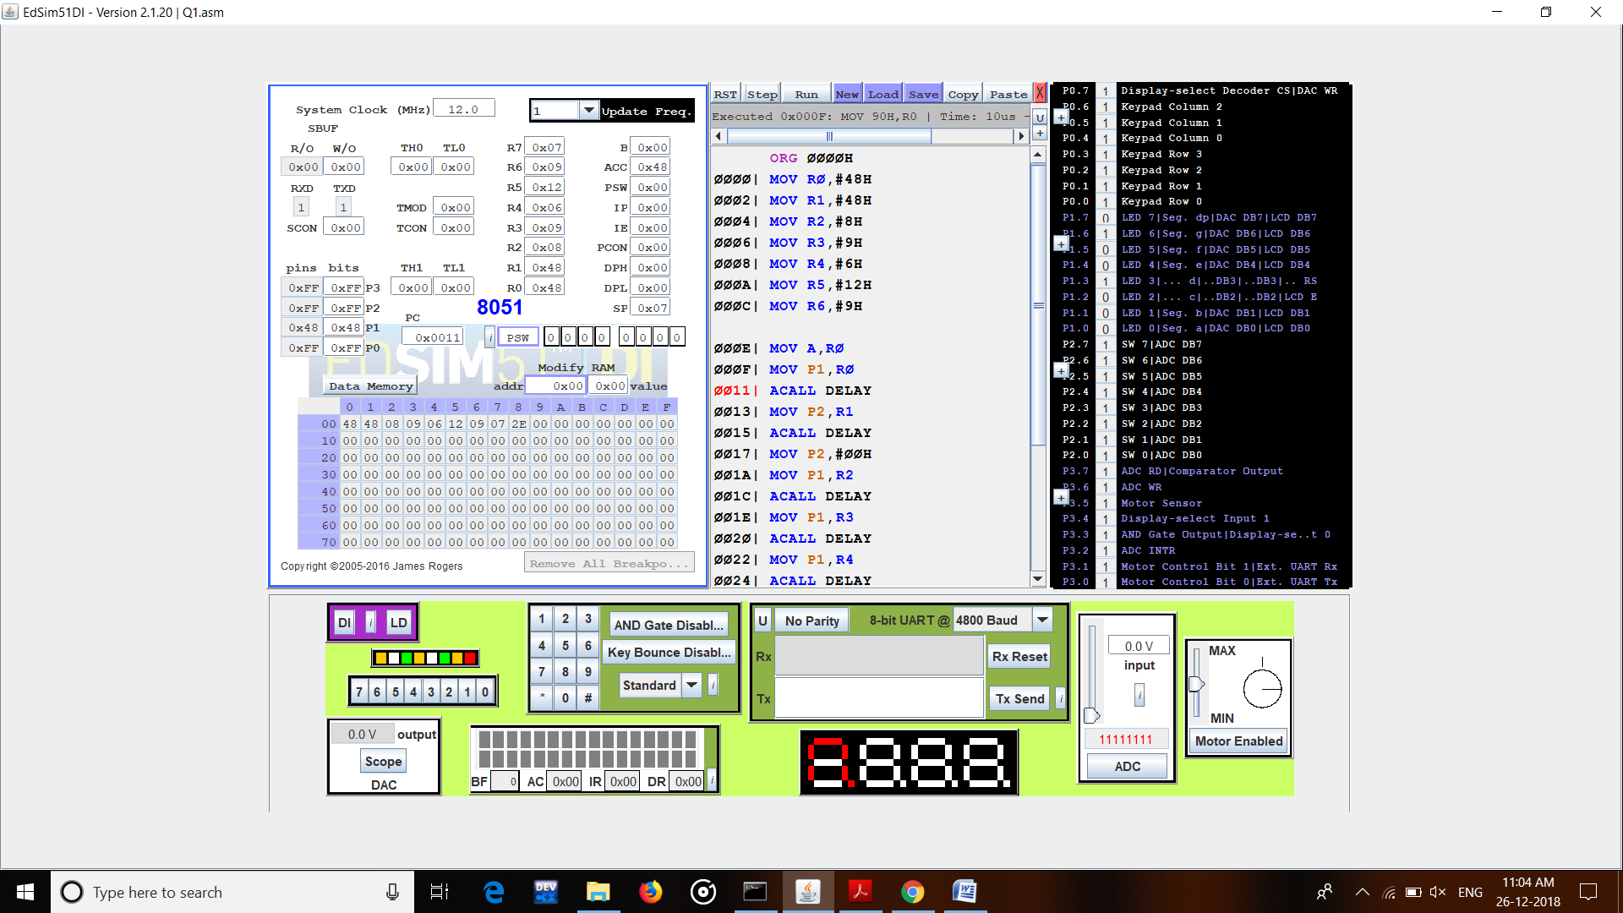

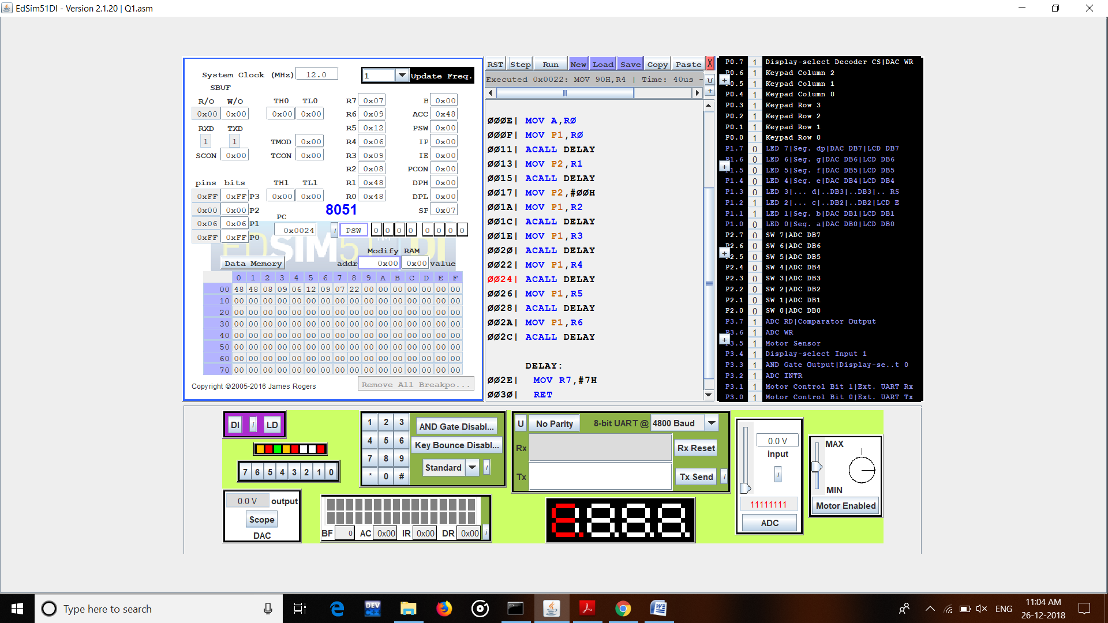

Q2:

ORG 300H

DB 1,2,3,2,3,4,3,25,5,6,8,7

ORG 700H

DB 4,3,4,5,6,55,2,2,3,4,5

ORG 0000H

MOV R7, #0CH

MOV A, #00H

MOV R0, #00H

MOV R6,#00H

LOOP:

MOV 70H,#00H

MOV DPTR, #0300H

MOV A,R0

MOVC A,@A+DPTR

MOV R2,A

MOV DPTR, #0700H

MOV A,R0

MOVC A,@A+DPTR

ADD A,R2

MOV 70H,A

MOV A,#00H

MOV R2,#00H

INC R0

DJNZ R7, LOOP

END

